**Lab MST WorkSheet:- 1**

**Student Name:** Vivek Kumar **UID:** 21BCS8129

**Branch:** BE-CSE (LEET) **Section/Group:** 20BCS-809/A

**Semester:** 4th Sem **Date of Performance:** 15/03/2022

**Subject Name:** SE Lab **Subject Code:** 20CSP-255

**AIM: -** What is the importance of DFD explain with example and Draw the DFD of food ordering system?

1. **Importance of Data Flow Diagram:**

Process modeling involves graphically representing the processes or actions, that capture, manipulate, store and distribute data between a system and its environment and among component within the system. A common form of a process model is a data-flow diagram (DFD).

A process model is a formal way of representing how a business system operates. Through structural analysis technique called data flow diagram, the system analyst can put together a graphical representation of data processes throughout the organization. The purpose of data flow diagram is to show the “flow” and transformation of data through the system. These diagrams are used as visualization tool to help the audience get a better idea of what exactly is going on in the system.

**The DFDs are used to:**

1. Discuss with the user a diagrammatic interpretation of the process in the system and clarify what is currently being performed.  
2. Determine what the new system should be able to do and what information is required for each different process they should be carried out.  
3. Check that the completed system conforms to its intended design.  
4. Provides easy presentation and communication between technical and non-technical staff.

Using any convention’s DFD rules or guidelines, the symbols depict the four components of data flow diagrams.

1. **External entity:** an outside system that sends or receives data, communicating with the system being diagrammed. They are the sources and destinations of information entering or leaving the system. They might be an outside organization or person, a computer system or a business system. They are also known as terminators, sources and sinks or actors. They are typically drawn on the edges of the diagram.
2. **Process:** any process that changes the data, producing an output. It might perform computations, or sort data based on logic, or direct the data flow based on business rules. A short label is used to describe the process, such as “Submit payment.”
3. **Data store:** files or repositories that hold information for later use, such as a database table or a membership form. Each data store receives a simple label, such as “Orders.”
4. **Data flow:** the route that data takes between the external entities, processes and data stores. It portrays the interface between the other components and is shown with arrows, typically labelled with a short data name, like “Billing details.”
5. **Example of the DFD:**

Here’s the **Food Ordering System** **Data Flow Diagrams** discussing the DFD Levels from Level 0, 1. It gives clearer view of all the data included in Food Ordering System.

**Food Ordering System DFD Level 0:**

The Food Ordering System DFD level 0 is also known as context diagram. It’s an abstract view with the mechanism represented as a single process with external parties. This DFD for Food Ordering System depicts the overall structure as a single bubble. It comes with incoming/outgoing indicators showing input and output data.  
The processes are represented by a square box, the external entities (users) are shown by the rectangular shape box and the arrows with labels are the data that flows in the system.

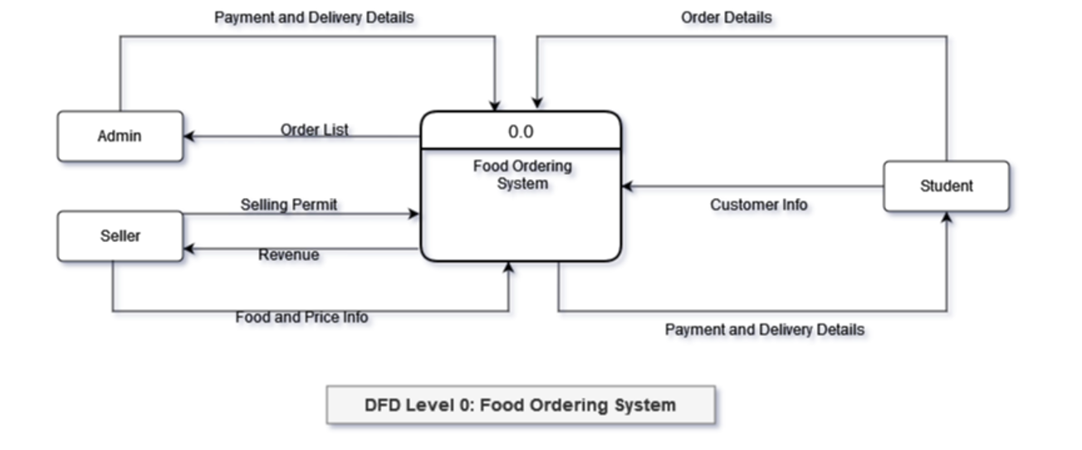

**Food Ordering System DFD Level 1:**

Next to the context diagram is the level 1 data flow diagram. The content of Food Ordering System DFD level 1 must be derived from the context diagram and will be broken down into sub processes.  
In this level, the illustration must display or reveal further processing information. So the Food Ordering System Data Flow Diagram Level 1 revealed the sub-processes when doing a transaction at Food Ordering stalls. The idea presented here were derived from the main process of Food Ordering System DFD Level 0.

